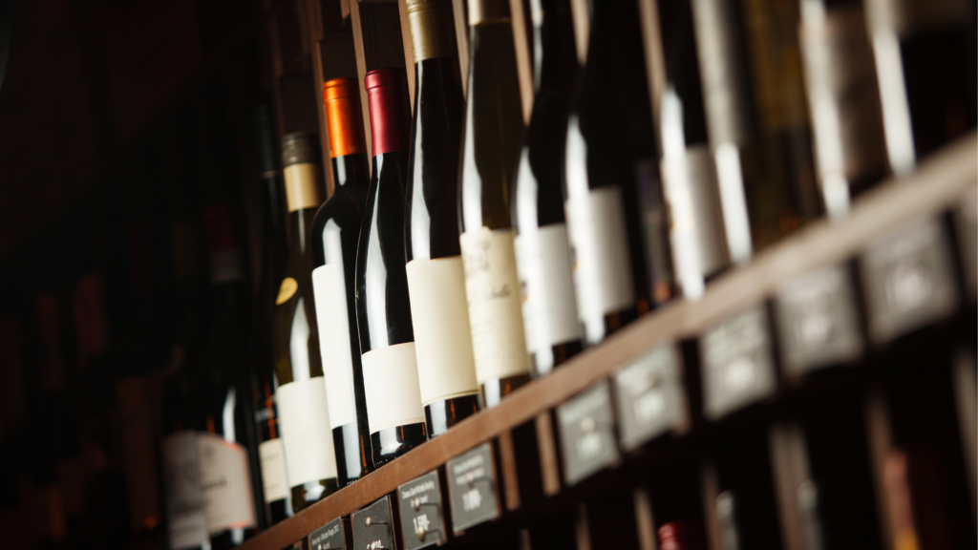

**Mission**

To create and promote premium, eco-conscious wines that celebrate the heritage and natural abundance of Ziro Valley while fostering sustainable growth and empowering local communities.

**Vision**

To become a globally recognized artisanal wine brand that epitomizes quality, sustainability, and cultural richness, offering unique flavors that resonate with diverse audiences.

**Core Values**

* **Sustainability**: Commitment to eco-friendly practices and responsible farming.
* **Quality**: Delivering premium products crafted with care and authenticity.
* **Community Empowerment**: Supporting local farmers and artisans.
* **Innovation**: Continuously evolving to offer diverse and unique flavors.
* **Customer-Centricity**: Ensuring exceptional experiences for our consumers.

**General Structure of the Strategy**

**Market Segmentation**

* **Geographic**: Expand beyond Arunachal Pradesh into metro cities (Delhi, Mumbai, Bangalore) and explore international markets.
* **Demographic**: Focus on millennials (ages 25–40), Gen Z, and upper-income groups seeking premium, artisanal products.
* **Psychographic**: Appeal to eco-conscious and health-aware consumers as well as wine connoisseurs.
* **Behavioral**: Target tourists and celebratory buyers.

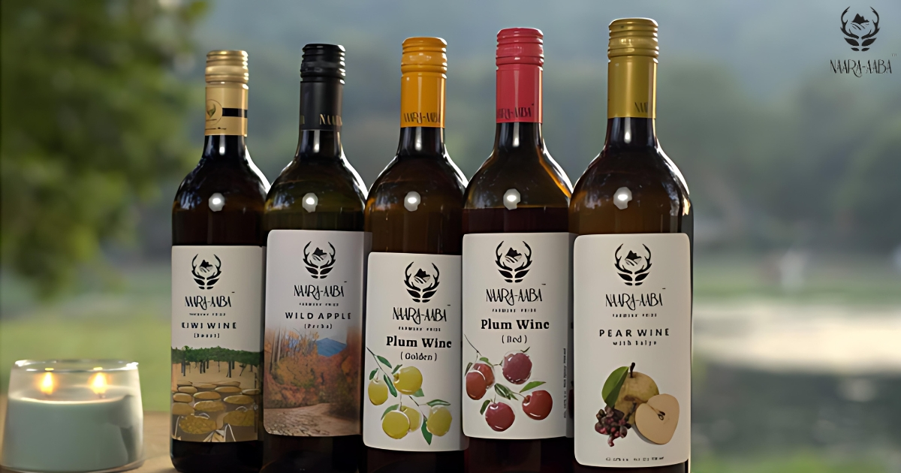

**Product Strategy**

1. **Product Diversification**:
   * Expand the product line by introducing new flavors like apple, kiwi-plum blends, and sparkling wines.

Products:

* Kiwi wine: The first organic kiwi wine in India, made from November to January
* Guava Chilli: A wine made with guava
* Guava Delight: A wine made with guava
* Rose: A wine made with rose
* Golden Plum: A wine made with golden plum
* Red Plum: A wine made with red plum
* Pear with Salyo: A wine made with pear and a local dry fruit called salyo
* Wild Apple: A wine made with wild apple
  + Develop limited-edition variants tied to seasons or cultural events.
  + Focus on eco-conscious packaging to align with sustainability values.

1. **Competitiveness**:
   * Highlight the unique origin story of Naara Aaba, emphasizing its Himalayan roots.
   * Use premium ingredients and artisan production methods to differentiate from mass-produced wines.
   * Regularly innovate by launching new flavors and limited-edition collections to stay ahead of competitors.

**Pricing Strategy**

1. **Tiered Pricing**:
   * **Premium Pricing**: For flagship products, targeting high-income consumers. Price range: INR 1,200–1,800 per bottle.
   * **Promotional Pricing**: Discounted prices for new market entrants or limited-time offers. Price range: INR 900–1,100 per bottle.
   * **Bundle Pricing**: Combo offers for multiple bottles during festivals or events. Price range: INR 2,000–3,000 for three bottles.
2. **Competitive Pricing**: Analyze competitor prices in metro markets and adjust to remain competitive while maintaining premium positioning.

***Here are 4 effective wine pricing strategies:***

1. ***100% Mark Up Across The Board****: The ultimate appeal of this strategy is the ease. A twenty dollar bottle becomes forty. Many restaurants will choose to mark up more than 100%, or less, depending on what their guests are willing to support. For example, high-end establishments can often charge as high as 200% mark up whereas guests of more casual restaurants, like a pub or fast service spot, may experience sticker shock.*
2. ***Slide The Scales****: Your lowest priced bottle has the highest margins and your most expensive bottle has the lowest. A very good reason for choosing this strategy is that it doesn’t punish people for liking costly wines. The ultimate goal is to encourage those types of guests to frequent your restaurant. On one occasion I have seen a restaurant mark their highest priced wine up by only five dollars and this resulted in a semi-viral marketing technique for them. Everyone was talking about the fact you could drink a flossy Champagne for the same price as you would on your own couch.*
3. ***The Pinot Grigio Tax:*** *If you know your guests will automatically order a certain varietal – typically Pinot Grigio or Chardonnay for whites. Malbec, or Cabernet Sauvignon for reds – choose to make the most profit off those fast-moving bottles. If you have something special or eccentric, charge less for those. Again, this fosters an environment for the foodie influencers to return and as the connoisseur of their friend groups, to talk about your restaurant as a destination for wine.*
4. ***All Wines Were Created Equal****: Charge exactly the same for everything and choose wines within a ten dollar price variance. This is one of the most rarely chosen strategies but there are several benefits. Because it is so unusually seen this creates a talking point about your restaurant. Unlike any other method, you will discover what your guests most want without price being a driving factor.*

**Promotional Strategy**

1. **Unique Selling Proposition (USP)**: Artisanal wine crafted from Himalayan pears and plums with a focus on sustainability and community development.
2. **How It Differs from Competitors**:
   * **Storytelling**: Unlike competitors, focus heavily on heritage and the brand’s ties to Ziro Valley.
   * **Exclusive Experiences**: Host vineyard tours and wine-tasting events at the Ziro facility.
   * **Collaborations**: Partner with luxury restaurants and eco-tourism platforms to enhance exclusivity.
3. **Promotional Channels**:
   * **Digital Marketing**: Use Instagram, Facebook, and YouTube to showcase the story behind Naara Aaba.
   * **Influencer Marketing**: Collaborate with wine connoisseurs and travel bloggers.
   * **Sampling Events**: Organize wine-tasting sessions in major cities.
   * **Seasonal Campaigns**: Launch campaigns during festivals and holiday seasons.

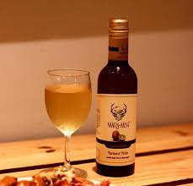

**Distribution Strategy**

1. **Evolution Over Time**:
   * **Initial Phase**: Distribution limited to Ziro Valley and nearby towns.
   * **Expansion Phase**: Partnership with wine shops across Arunachal Pradesh.
   * **Current Phase**: Distribution to metro cities and online platforms.
2. **Importance and Current Approach**:
   * Ensure nationwide availability through partnerships with premium wine retailers.
   * Strengthen online presence via e-commerce platforms like Amazon and Flipkart.
   * Implement a subscription model to drive recurring sales.
3. **Future Goals**:
   * Explore export opportunities to eco-conscious international markets.
   * Develop a robust supply chain to avoid stock-outs and delays.

**Metrics to Track Performance**

1. **Sales Metrics**:
   * **Revenue Growth Rate**: Aim for a 15–20% annual increase.
   * **Units Sold**: Monitor total units sold monthly across regions.
2. **Customer Metrics**:
   * **Customer Retention Rate**: Target 70% retention for recurring buyers.
   * **Churn Rate**: Reduce churn to below 15% annually.
   * **Customer Lifetime Value (CLV)**: Calculate the long-term profitability of customers.
3. **Marketing Metrics**:
   * **Brand Awareness**: Social media impressions, shares, and mentions.
   * **Campaign ROI**: Return on advertising spend for digital campaigns.
4. **Product Metrics**:
   * **Flavor Success Rate**: Percentage of sales from new flavors.
   * **Customer Feedback**: Scores and reviews from surveys and online platforms.
5. **Operational Metrics**:
   * **Distribution Efficiency**: Measure time from production to retail delivery.
   * **Stock Availability**: Ensure 95% product availability in all markets.

**Implementation and Recommendations**

1. **Phase 1: Awareness Campaigns**
   * Focus on digital and influencer marketing to build brand visibility.
   * Conduct wine-tasting events in metro cities.
2. **Phase 2: Strengthening Distribution**
   * Partner with logistics providers to streamline supply chains.
   * Expand online presence and offer exclusive deals on e-commerce platforms.
3. **Phase 3: Product Diversification**
   * Launch new flavors and seasonal variants to cater to diverse preferences.
4. **Phase 4: International Expansion**
   * Explore export opportunities and participate in global trade fairs.
5. **Continuous Monitoring**
   * Regularly track metrics to evaluate the success of strategies and adapt as needed.

